Poverty
Impact Score
0 22-26 30
In the U.S., poverty refers to individuals and families whose income is below the Federal Poverty Guideline. The Federal Poverty Guideline in 2016 was $11,880 for an individual and $24,300 for a four-person household.
Health Impacts  Increased risk of:  - Poor academic achievement  - Crime  - Greater health expenditures  - Inadequate nutrition  - Food insecurity  - Some studies have shown a 2 times increased risk of Coronary Heart Disease | Comparison  Percent of Population Below Federal Poverty Guideline, Marion Co. vs. other locations, 2016  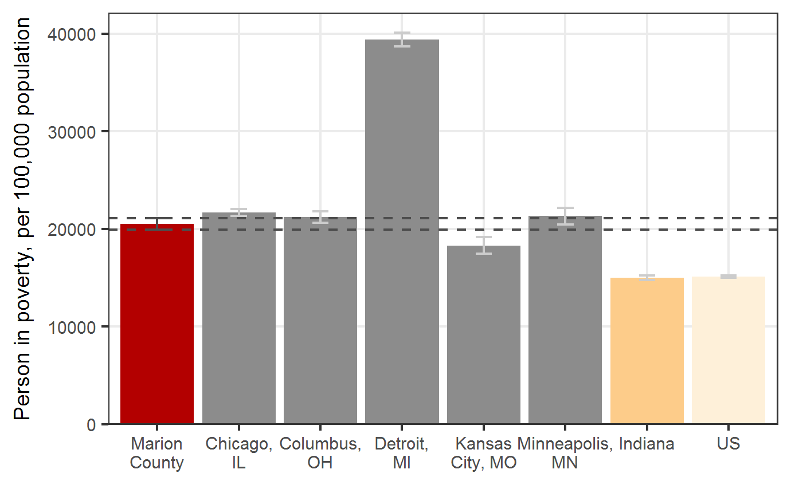  Source: ACS 5 Year Summaries, 2010-2016
Treatment  - Policy Changes  - Social Reform | Trend  Poverty, Marion Co. 2012-2016  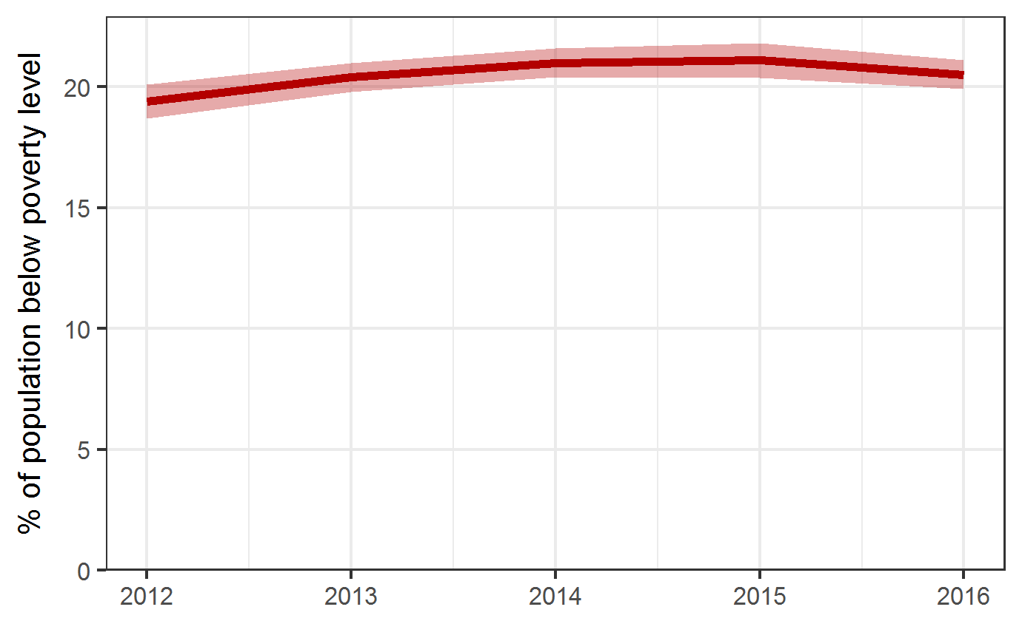  Source: ACS 5 Year Summaries
DR3780

Risk Factors
Risk factors for poverty in childhood include low parental education (where parents both lack a high school degree), non-employed parents, teen mothers, single-parents, large families with four or more children, children in families who have changed residences one or more times in the last 12 months, and households without English speakers.
Source: NCCP, National Center for Children in Poverty

Equity
Percent of Population Below Federal Poverty Guideline in Marion County, by Race
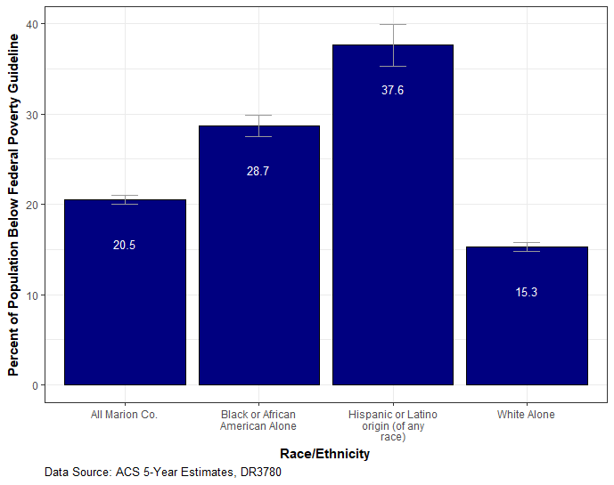
Percent of Population Below Federal Poverty Guideline in Marion County, by Educational Attainment for those 25 years and over
